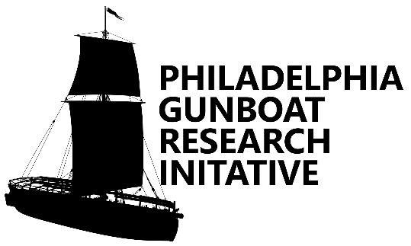
Institute of Nautical Archaeology & Texas A&M University
Plattsburgh, NY
Dates: June 30th - July 21st, 2024
Application Form

NAME: ______________________________________________________________________
ADDRESS: ___________________________________________________________________
CITY: ____________________________ STATE: ______________ ZIP: ________________
PHONE: ______________________ E-MAIL: _______________________________________
EMERGENCY CONTACT:____________________________________________________________________
PHONE: ___________________________________
Diving Information
Dive Cert. Agency: _________________________ Cert. Number: _______________________
Cert. Level:__________________ Year Cert.:___________ Approx. # of Dives: ___________
All divers must be cleared by the Texas A&M University Archaeological Diving Control Board and the Institute of Nautical Archaeology Diving Safety Officer.
(see nauticalarch.org/diving-safety/ and liberalarts.tamu.edu/anthropology/archaeological-diving/ for details)

On a separate page, please answer the following questions:
- What experience do you have that you think will be an asset to the project team?
- What is the reason you would like to participate in this project?
- What goals would you like to achieve if you are part of the team?
Please attach a copy of your current resume/CV
Email completed application forms to dostalc@tamu.edu

